Baton Rouge RC Club Newsletter –April 3, 2007



PRESIDENT: Farley Phillips
VICE PRESIDENT: Mike Goetzman
SECRETARY: Richard Mason
TREASURE: David Magee
EDITOR: Pat Beard
Telephone: (225)654-8162
E-mail: pcbeard@cox.net

________________________________________________________________________________________________________
NOTICE:
The next meeting of the BRRCC will be Tuesday, May 1st at the Greenwell Springs Rd. Library at 7:00pm
_______________________________________________________________________________________
Are you interested in improving your photography skills?

Then I hope the following information can help. I am a very avid photographer and have been using 35mm format cameras for 30+ years. I would like to share with you some of the basics I have learned through the years. Some of the photographs shown here were used in previous newsletters. Much of the information presented here I learned from a pamphlet “Tips For Forest Photographers”, published by the US Forest Service.

What makes a good Picture, a usable picture?

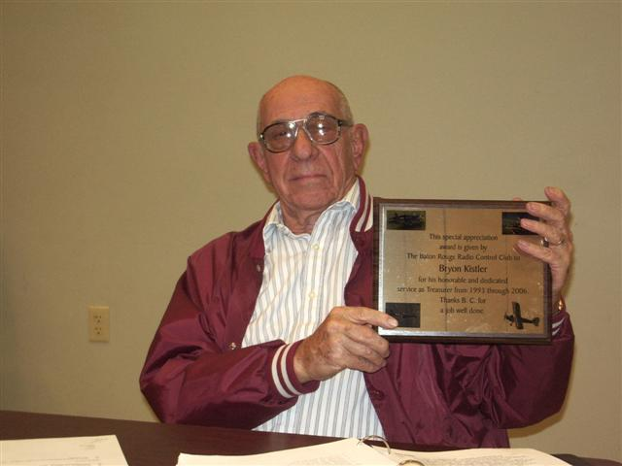
- Tells a story:

This picture shows BC with his well deserved award for service to BRRCC. It is a simple picture and is direct to the point with no back ground clutter. It would have been better if taken with BC in the act of receiving the award.

- Is it easy to understand?
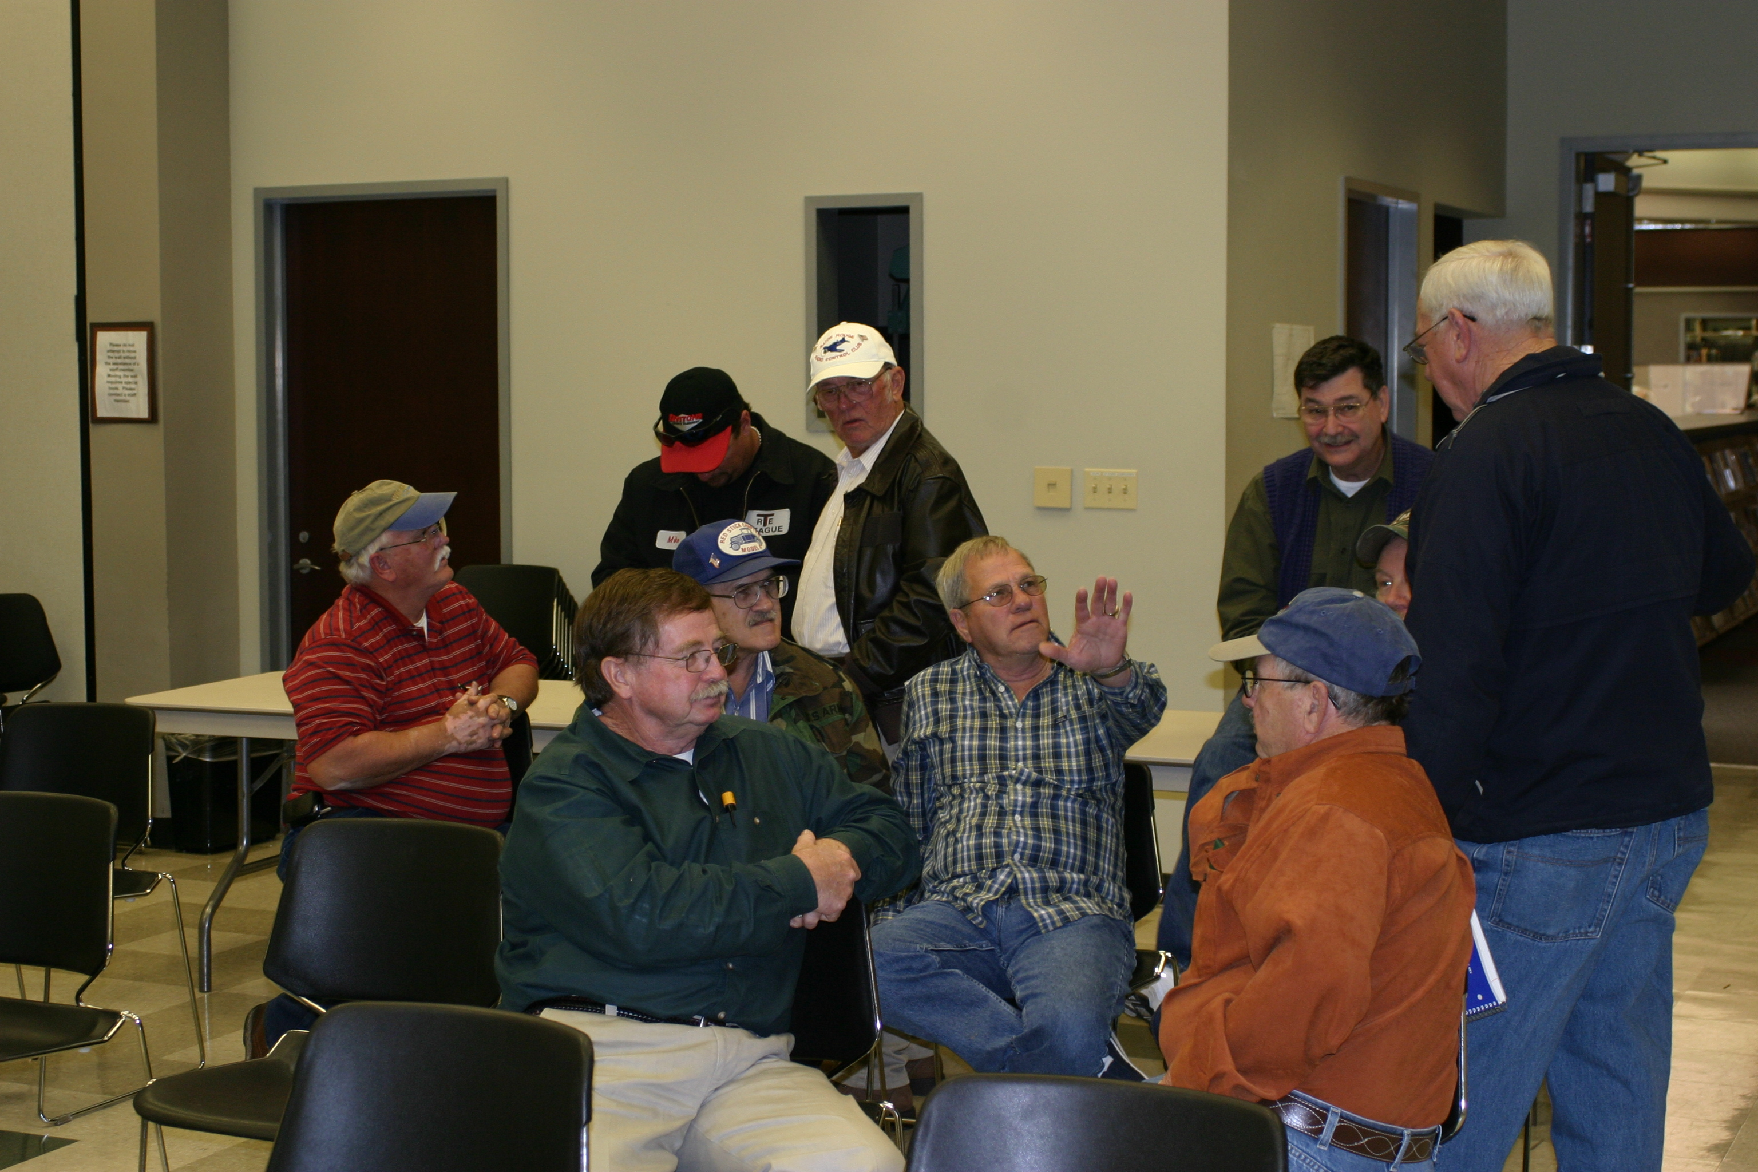
What is the story or point of this picture? Weldon seems to be making a point.

- Has minimum of “Dead” space”:
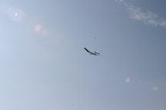
We have all taken pictures like this and they are really of no value. A long telephoto lens is needed for this type of picture.

- Is not cluttered:

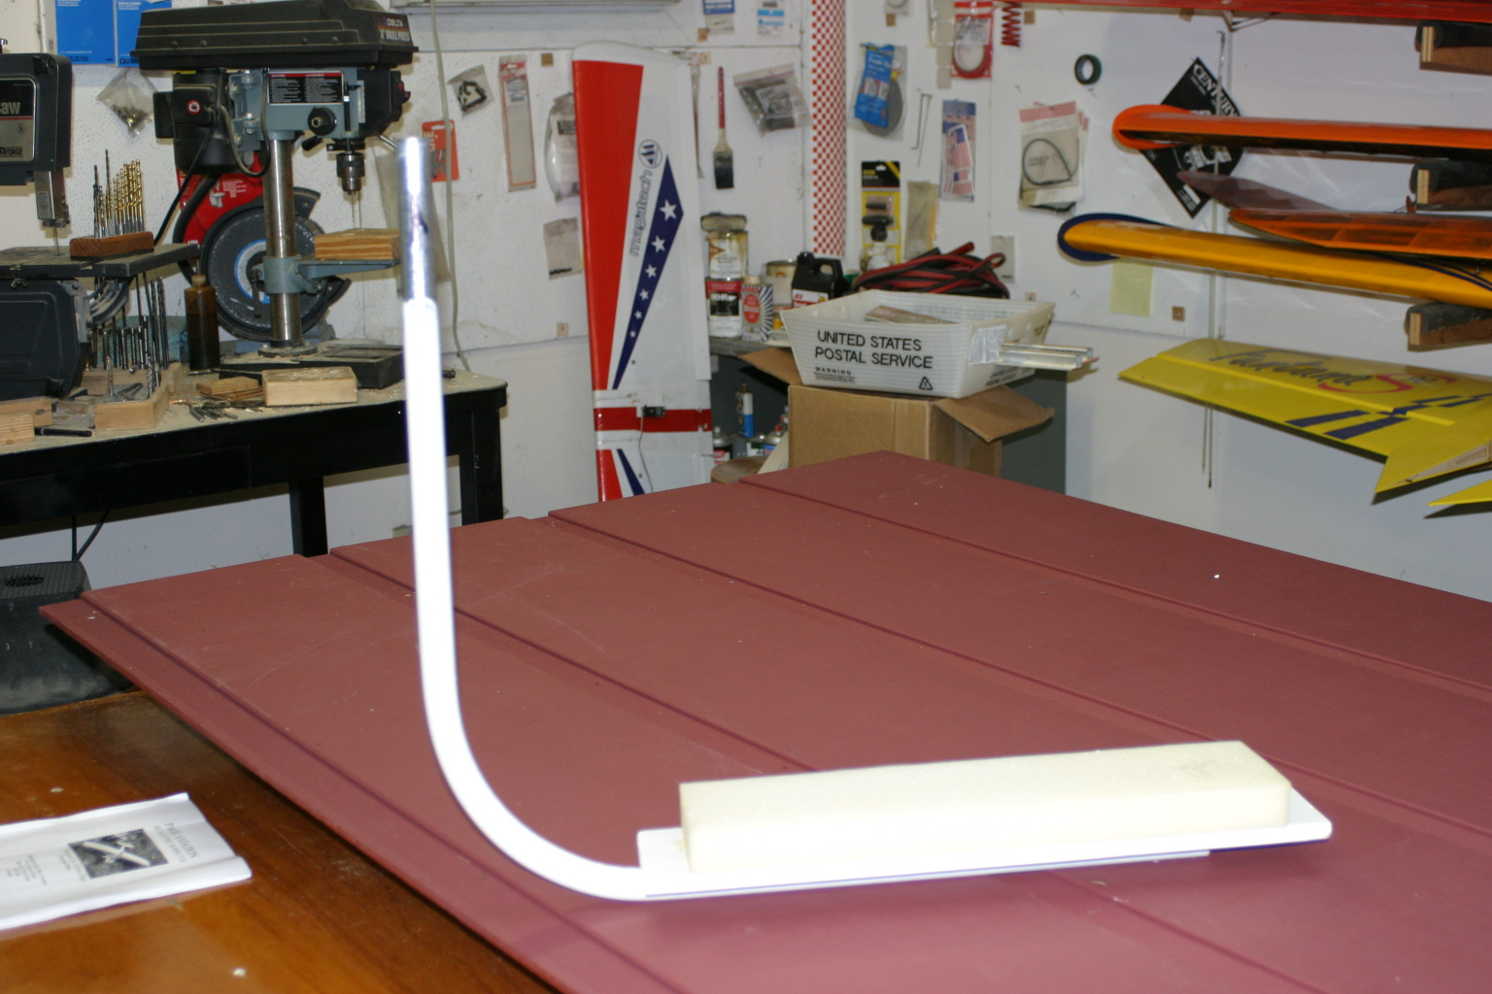
Some times we do not have a lot of control over the back ground. A little preplanning can eliminate this problem.

5. Is not “Dead-Centered”:

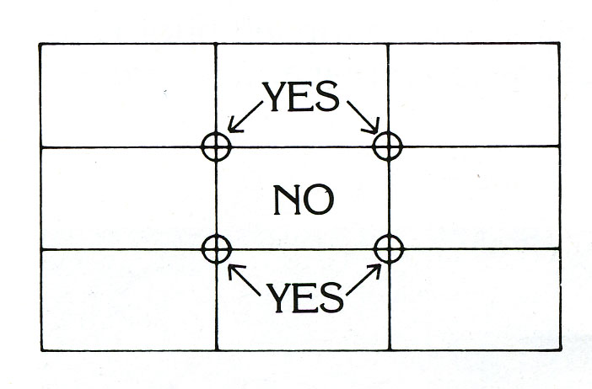
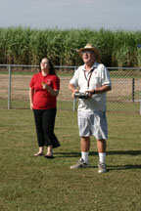
Don’t make your subject a “bulls-eye” in the picture area. Place the main point of interest at one of the four grid points. Have people, animals, machines facing into the rest of the photo, not looking into an edge.

Here Charlie is facing into the picture but not dead center.

Record Shots- Mainly Informational

Many of the photos we take are informational and these shots do not need to be artistically excellent, but should be sharp, well-lighted, and close enough to show detail necessary. Still, try to follow as many of the above rules as possible.
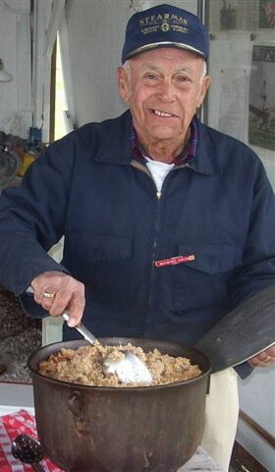
Examples:

1. People doing a service for the club such as Blackie and his famous jambalaya.

2. Scale documentation:

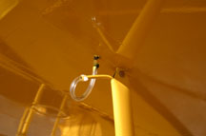

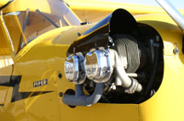

- Points of interest:

Club officers or new members.

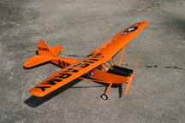
Planes you have built

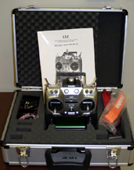
New products
Camera Mechanics:

- Aperture: Aperture is the opening in the camera lens that allows light to pass through to the film or image sensor of a digital camera. It can be compared to the iris of your eye in that it opens and closes to control the amount of light entering the camera. It is stated as “f-stops” and ranges from 1.2 – 32. The smaller the number the larger the opening; thus, a lens with an f-stop of 2 or below is called a fast lens and is great for low light situations. The higher the f-stop, the smaller the lens opening, the less light entering the lens and the greater the “Depth of Field” (the area in focus in front of and behind the subject of the photo).


- Shutter Speed: Shutter speed relates to how fast the shutter opens and closes; thus, also controlling the amount of light entering the camera. The faster the shutter speed, the better are the chances of stopping the motion of an airplane in flight. For low light situations you need a slower shutter speed and a lower f-stop to allow as much light as possible to enter the lens.

The diagram below shows the relation ship between Aperture and Shutter Speed. Understanding this allows you to better control camera settings to get the picture you desire.
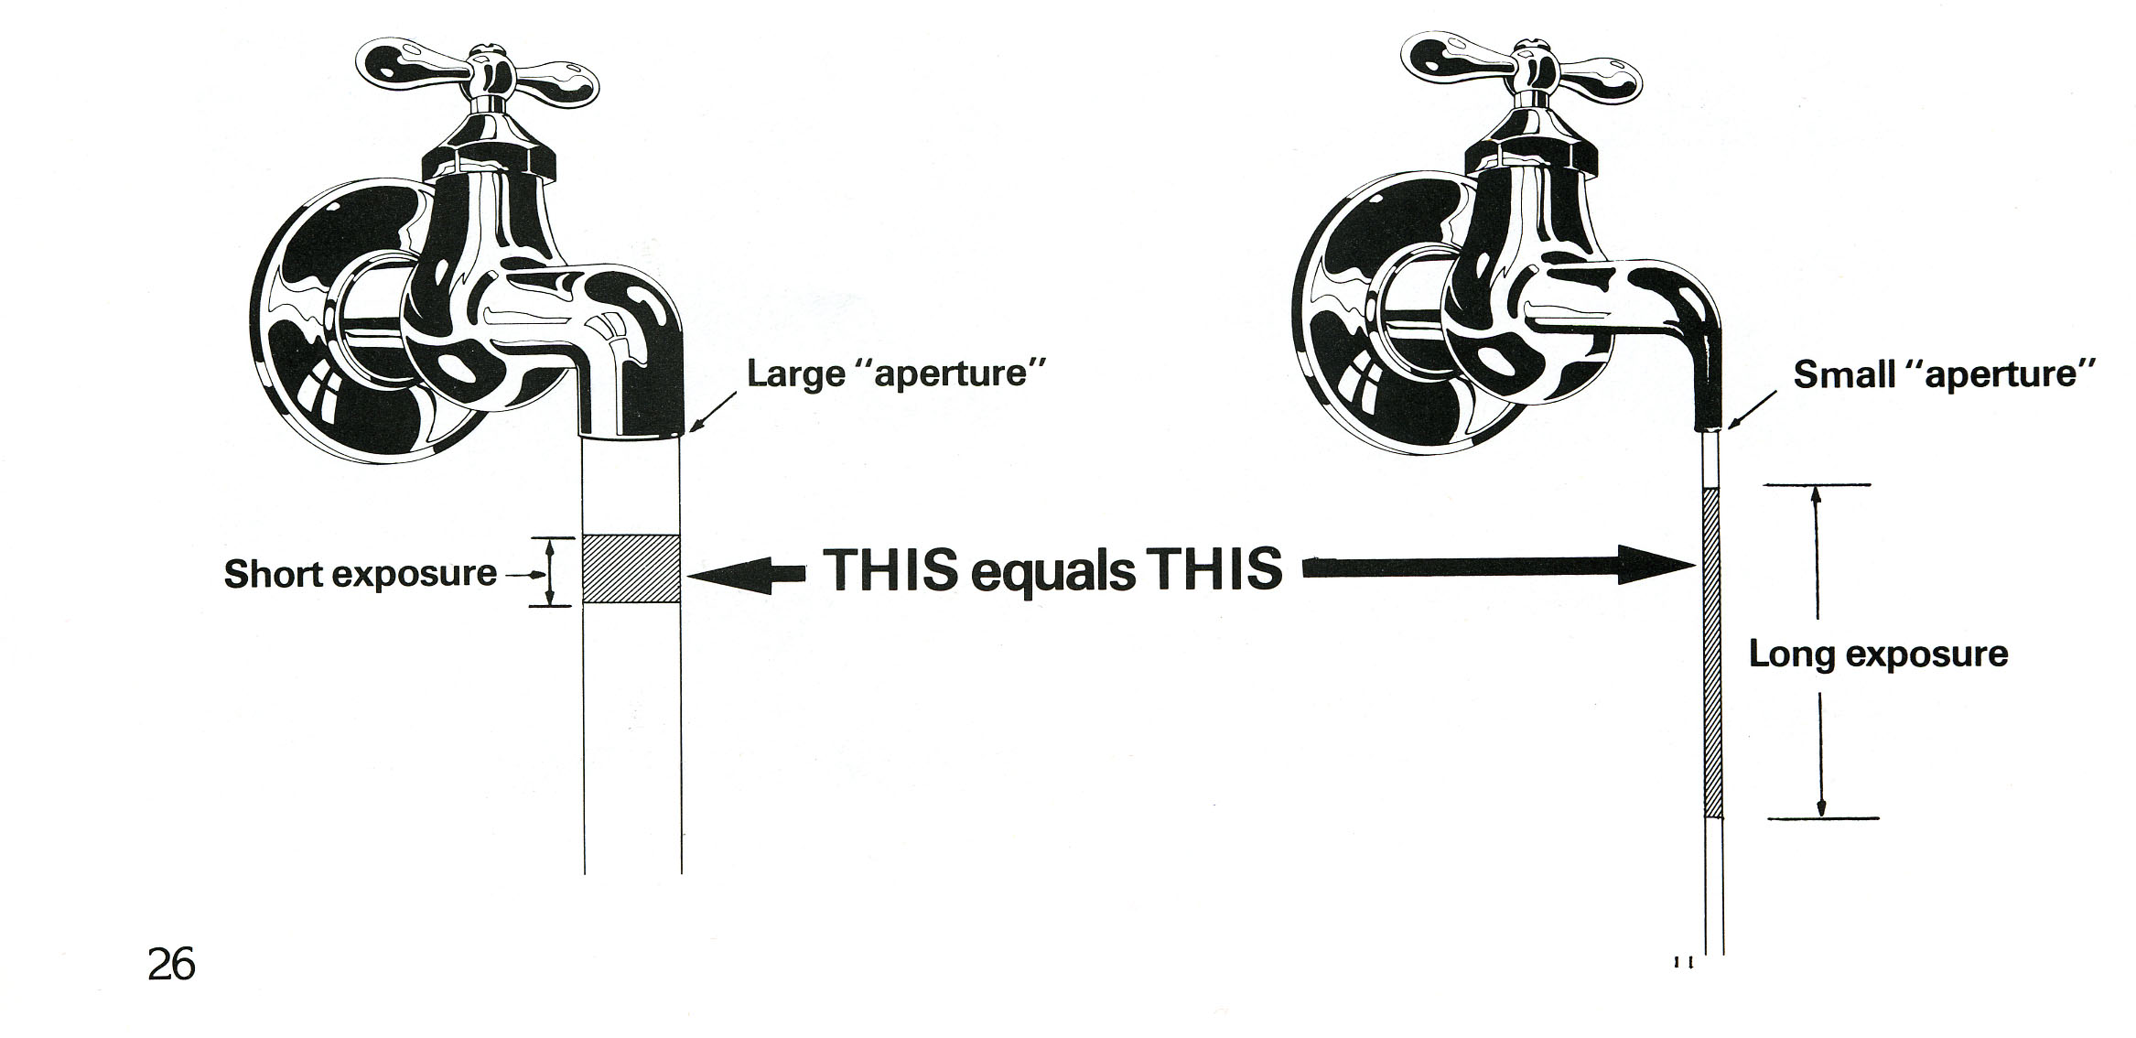
A note on Film Speed:

Film speed is a number given to film in relation to how fast it reacts to light. The faster the films speed, the less light needed to record the image. This number is stated as ISO and is posted on the film container. The higher the number, the faster the film speed and the better for taking pictures in low light situations.

How to apply camera mechanics:

- Which Shutter Speed?

General Rule: (use the fastest speed you can and still retain the aperture you need to get the picture.

Why? As the diagram below shows, a tiny jiggle of the camera (such as caused by your heart beat or snapping the shutter button) can mean a lot of apparent subject movement. If the front of the camera moves as little a 1/100th of and inch as you trip the shutter, the image “moves” an equivalent of 1 foot in 100 yards, or 171/2 feet at one mile. This movement is magnified when using long telephoto lenses or the telephoto mode of your digital camera.
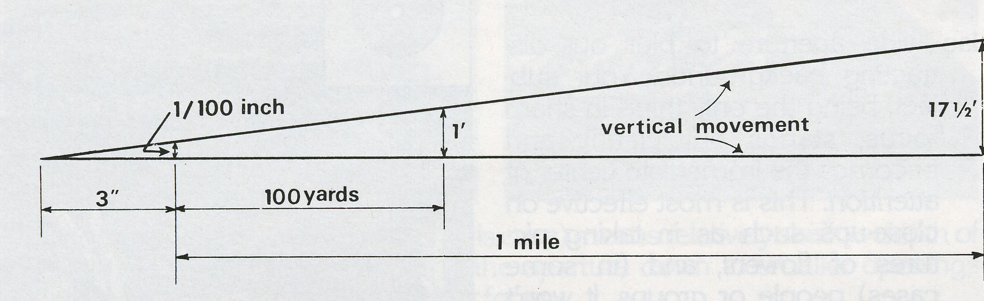

Hunters know how important it is to control their breathing and gently squeeze the trigger when getting ready to fire at a target. The same holds true for taking a picture.

The faster shutter speeds tend to dampen down subject “movement”. Thus when shooting distant objects where depth of field is not a factor, use the fastest shutter speed you have available.

- Which Aperture (f-stop)?

General rule: (Use the aperture that will give you the depth of field you desire. Determine which objects you want in focus.

Depth of field increases as you make the aperture smaller. Single lens reflex (SLR) cameras have a depth of field preview button so you can see what is in focus prior to taking the shot.

Use a wide aperture (small f-stop) to blur out distracting backgrounds. Your subject, being the only thing in sharp focus (figure 1) and stands out clearly and becomes the immediate center of attention. This is most effective on close-up pictures and can be used to some extent when you want to isolate one plane from a line of planes on the flight line.



Figure 1 – in this photo I wanted only the flowers to be in focus so I used the lowest f-stop my camera would allow. The grass, in front of and behind the flowers, is out of focus.
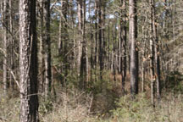

Figure 2 – In this photo I wanted everything to be in focus so I could describe the timber to an absentee landowner. I used the highest f-stop I could for the amount of light in a forest situation.

I hope this information will help you become a better photographer..

REMEMBER:

- Always take a few extra seconds to see what you are viewing through the camera lens (you do not want to cut off feet or heads of people if the intent is to get all of them in the photo).
- Remove any unwanted debris or other items that may clutter the picture.
- Make sure your shadow is not in the picture.
- When you get your pictures home or view them on the computer, critique them to see how you might have made them better. This is one of the best ways to improve your photography.
- Watch movies on TV and observe how people and scenery are framed.
- and practice, practice, practice. To me this is the fun part and is not expensive when you own a digital camera.

Please do not hesitate to give me a call if you have questions about photography and especially if you have an idea for a newsletter.

Pat Beard – Editor

